

**BLENDA, BHATAR, PURBA BURDWAN, PIN-713125**

**GSTIN NO: - 19AALCR7084B1Z3, PAN NO: - AALCR7084B, CIN NO: - U34100WB2022PTC252240**

**MOBILE NO: - 7384948494**



FORM 22

[See rules 47(g), 124 (2) 126 & 127 (1)]

INITIAL CERTIFICATE OF COMPLIANCE WITH POLLUTION STANDARDS, SEFETYSTANDARDS OF COMPONENTS AND ROAD WORTHINESS



(FOR VEHICLE WHERE BODY IS FABRICATED SEPARATELY) PART-1

(To be issued by the manufacturer)

RIJI ER

RIJIYA TRADING PVT LTD

**- MD9120EP3CW964029**

MD1200W964029

**COMPLIED WITH THE PROVISE OF THE MOTOR VEHICLE ACT.1988 AND RULES MADE THERE UNDER.**

**For, RIJIYA TRADING PVT LTD**

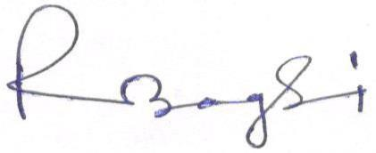

**Signature of the Chassis manufacture**